Coffee Shop Web-Based Inventory Management System (WIMS) at Senior High School Expo 2023 of STI College Marikina

Juztin Nicolo Abamo

Ryan Jeoffrey V. Lorenzo

Diesel Jan S. Pedro

Leslhynne Tator

STI College­ – Marikina

April 2023

**CHAPTER I**

**THE PROBLEM AND ITS BACKGROUND**

This chapter contains with the study's background, current state of the technology, statement of the problem, objectives of the study, scope and delimitation, significance of the study, and definition of the terms.

**Background of the Study**

A sales monitoring system is a software program or connected series of programs that tracks, manages a company's sales information and inventory information. It can gather and compile information from multiple sources and store sales data about your customers and products. The system will be designed to enable coffee shop owners to manage their inventory efficiently and effectively, with features such as inventory tracking, real-time stock updates, purchase order generation, and sales tracking.

STI College is a private educational institution that offers programs in information and communications technology, business and management, hospitality and tourism management, arts and sciences, and engineering. Established in 1983, the college has over 70 campuses located across the country and a reputation for producing highly skilled graduates. STI College is committed to providing a holistic learning experience to its students, with extra-curricular activities, student organizations, and a strong research program. Overall, STI College is a recognized leader in providing quality education in the Philippines for nearly four decades, adapting to the changing needs of the society and the global economy. Google (2023)

STI College Marikina is organizing the Senior High School Expo 2023, where senior high school students will highlight their skills and knowledge in various fields, including business and entrepreneurship. For this event, a coffee shop will be set up to provide refreshments for the attendees. To ensure smooth operations, an efficient inventory management system is needed to track inventory levels, monitor sales, and avoid stockouts.

The study is to develop a WIMS specifically designed for a coffee shop. The system will be designed to enable coffee shop owners to manage their inventory efficiently and effectively, with features such as inventory tracking, real-time stock updates, automatic purchase order generation, and sales tracking. This system will not only benefit the coffee shop at the Senior High School Expo 2023 but can also be utilized by coffee shops in the community to improve their inventory management processes.

The development of a WIMS for coffee shops can lead to improved operational efficiency, reduced costs, and increased profitability. By addressing the inventory management challenges faced by coffee shops, this project can provide practical solutions to support the growth and sustainability of the coffee shop industry.

**Statement of the Problem**

**General Problem**

This research seeks to develop and design a Web-Based Inventory Management System for a Coffee Shop at Senior High School Expo 2023 of STI College Marikina

**Specific Problems**

1. How to develop and design a WIMS?
2. How to develop and design a database that will serve as a storage of user information?
3. How to develop and design a POS Module?
4. How to develop and design a module for the administrators that will assist in maintaining the system?
5. How to implement a user-friendly interface that allows for easy navigation and access to information?

**Objective of the Study**

**General Objective**

This research seeks to develop and design a Web-Based Inventory Management System for Coffee Shop at Senior High School Expo 2023 of STI College Marikina

**Specific Objective**

1. To develop and design a WIMS?
2. To develop and design a database that will serve as a storage of user information?
3. To develop and design a POS Module?
4. To develop and design a module for the administrators that will assist in maintaining the system?
5. To implement a user-friendly interface that allows for easy navigation and access to information?
6. To ensure the system's security and prevent unauthorized access to sensitive information?

**Scope and Limitations**

The scope of this research paper is focused on the development and design of a web-based inventory management system specifically for the coffee shop at the Senior High School Expo 2023 of STI College Marikina.

The limitations as well, the limitation of the WIMS designed for the coffee shop at the Senior High School Expo 2023 of STI College Marikina is that it does not have the capability to process online payments. The system serves as a tool for recording transactions.

**Significance of the Study**

The research study has significant public implications because it can relieve important distress and enhance an individual's overall quality of life. Furthermore, it can be used as a reference for the mentioned people in the future, as it will aid them in continuing to support the goals of the research, responding to the problem, and gaining additional knowledge from the research.

The study will benefit the following:

**Student -** This project will be helpful for students, as it serves this study to test and enhance their skills and knowledge about web development.

**STI College Marikina -**This system will be usable for any events that will be held at STI College and will serve as a foundation for a more efficient way of managing inventory.

**Future Researchers and Developers -**This research will serve as a guide or reference for developing or modifying a tabulation system for future studies.

**Senior High School Expo 2023 Attendees.** The attendees of the Senior High School Expo 2023 can benefit from the efficient inventory management system that will be implemented in the coffee shop. This system will ensure that they will have a sufficient supply of refreshments throughout the event, enhancing their overall experience.

**Definition of Terms**

**Database Management Software**- is a software program that is used to manage data. It allows for the storage, retrieval, and manipulation of data in a database. DBMS can be used to manage various types of data, including customer data, inventory data, and sales data.

**Entrepreneurship** - Entrepreneurship is the process of developing, organizing, and running a new business to generate profit while taking on financial risk.

**Inventory Management** - Inventory management, a critical element of the supply chain, is the tracking of inventory from manufacturers to warehouses and from these facilities to a point of sale. The goal of inventory management is to have the right products in the right place at the right time.

**Inventory Management System** - is a process that assists in controlling and monitoring the inventory levels of an organization. It is a tool that is used to help businesses manage inventory levels, track inventory movements, and generate reports on inventory-related activities. It involves managing inventory, from ordering to shipping, in a way that maximizes efficiency and profitability.

**Inventory Tracking** - Inventory tracking refers to the process of a business continuously monitoring all of the inventory that it owns. Inventory has several definitions, but it most commonly means raw materials, unfinished goods, and ready-to-sell items.

**Instock or stocked** - means that the product is available and ready for purchase.

**Module Design** - A modular design is an approach for product designing which is used to produce a complete product by integrating or combining smaller parts that are independent of each other.

**Point of Sale System**- is a software program that is used to process transactions and manage sales data. It is typically used in retail environments to manage sales, inventory, and customer data. The system allows for the tracking of sales data, including sales by item, sales by location, and sales by customer.

**Sale Module** - Sale Module implements functions of order placements, order scheduling, shipping, and invoicing. This includes the process of making Sales quotation, Sales order, Delivery note, Sales invoice, Debit note & their respective masters. Sales order can be made against sales quotation & also can be made manually.

**Security System** - is an important aspect of any system, particularly those that involve sensitive data.

**Stock Out** - A situation in which there are no goods of a particular kind available for sale: There were stock outs of the product at some locations over the summer holiday period.

**User Interface** - is an important aspect of any system, particularly those that are accessed by multiple users.

**WIMS** - A web-based inventory management system is a software program that is accessed through a web browser. It allows users to manage inventory data from anywhere and at any time with an internet connection. This type of system provides greater flexibility compared to traditional, locally installed inventory management systems, which are limited to a single device.

CHAPTER II

**REVIEW OF RELATED LITERATURE AND STUDIES**

This chapter discusses similar projects, concepts, and research related to our project and will aid future readers unfamiliar with technology in understanding the flow of the following project features.

**INVENTORY MANAGEMENT SYSTEM**

Inventory management system (IMS) is a process that assists in controlling and monitoring the inventory levels of an organization. It is a tool that is used to help businesses manage inventory levels, track inventory movements, and generate reports on inventory-related activities. It involves managing inventory, from ordering to shipping, in a way that maximizes efficiency and profitability.

The implementation of an inventory management system helps businesses reduce costs associated with excess inventory, stockouts, and waste. The system enables the tracking of inventory levels, reorder points, lead times, and demand patterns to ensure the right products are available at the right time. Additionally, the system provides real-time data, enabling businesses to make informed decisions about purchasing and selling products. Adhikari and Giri (2018)

**WEB-BASE INVENTORY MANAGE SYSTEM**

A web-based inventory management system is a software program that is accessed through a web browser. It allows users to manage inventory data from anywhere and at any time with an internet connection. This type of system provides greater flexibility compared to traditional, locally installed inventory management systems, which are limited to a single device.

Web-based inventory management systems are becoming increasingly popular, particularly for small and medium-sized businesses. Web-based inventory management systems can reduce the costs associated with hardware, software, and maintenance. Additionally, they provide real-time data, enabling businesses to make informed decisions about inventory levels, reorder points, and stockouts.

**POINT OF SALE SYSTEM**

A point of sale (POS) system is a software program that is used to process transactions and manage sales data. It is typically used in retail environments to manage sales, inventory, and customer data. The system allows for the tracking of sales data, including sales by item, sales by location, and sales by customer.

The implementation of a POS system can improve efficiency and accuracy in processing transactions. Additionally, it enables businesses to generate reports on sales data, which can be used to make informed decisions about product offerings, pricing, and promotions. Singh and Kaushik (2018)

**DATABASE MANAGEMENT SYSTEM**

A database management system (DBMS) is a software program that is used to manage data. It allows for the storage, retrieval, and manipulation of data in a database. DBMS can be used to manage various types of data, including customer data, inventory data, and sales data.

The implementation of a DBMS can improve efficiency and accuracy in managing data. Additionally, it enables businesses to generate reports on data, which can be used to make informed decisions about operations, sales, and marketing. Kim et al. (2018)

**SECURITY SYSTEM**

Security is an important aspect of any system, particularly those that involve sensitive data, security measures should be implemented to protect data from unauthorized access, modification, or destruction. Security measures can include user authentication, encryption, and data backups. Singh and Kaushik (2018)

**USER INTERFACE**

The user interface (UI) is an important aspect of any system, particularly those that are accessed by multiple users.

A good UI should be user-friendly, intuitive, and easy to navigate. Additionally, it should provide relevant information to users in a clear and concise manner. Singh and Kaushik (2018)

Overall, a web-based inventory management system with a user-friendly interface, a POS module, a DBMS, and adequate security measures can improve operational efficiency, reduce costs, and increase profitability.

**CONCEPTUAL FRAMEWORK**

**INPUT**

Inventory Data

Sales Data

User and Admin Information

**PROCESS**

Web-based inventory management system with point-of-sale module

Account Registration and Login Module

Inventory Sales Transaction Module

Admin Interface Module

**OUTPUT**

Coffee Shop Web-Based Inventory Management System (WIMS) at Senior High School Expo 2023 of STI College Marikina

Figure 1 illustrates how inputs are transformed into outputs and the associated tasks required. It presents a clear visualization of how customer data will be incorporated into the proposed system, as well as the steps necessary for converting inputs into outputs. After completing registration and logging in, student exhibitors can take advantage of the platform to add, modify, and delete product details. Moreover, they can capture product transactions and save customer information, including purchased items and payment methods used. To ensure smooth operations, an admin panel supervises the platform, producing sales reports and performing other necessary tasks. This comprehensive approach enhances the accuracy and efficiency of managing transactions, resulting in an improved overall customer experience.

**CHAPTER III**

**RESEARCH METHODOLOGY**

This chapter discussed the steps and methods utilized to carry out the research. It covers project design, project development, data flow diagram, and operating processes used to develop the system.

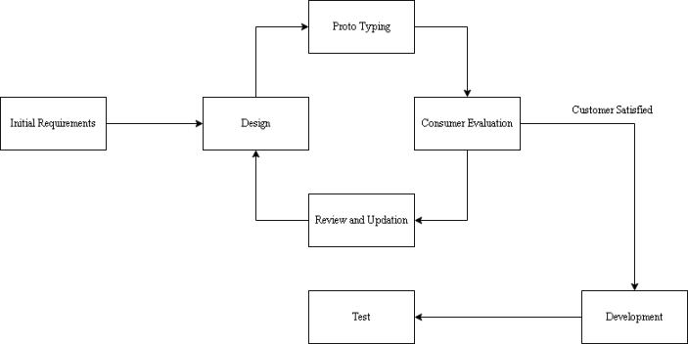**Project Design**

**Figure 2: Evolutionary Prototype Development Methodology for Web-Based Inventory Management System (WIMS)**

**Requirements Gathering**

Define the scope of the project, including the features and functionalities required.

**Initial Prototype Development**

Design a simple user interface to demonstrate the core features and navigation flow.

Gather feedback from coffee shop owners and stakeholders on the initial prototype.

**Iteration and Feedback**

Based on the feedback received, refine and enhance the prototype to address the specific problems identified.

**Database Design and Integration**

Develop and design a database schema that effectively stores user information, inventory data, sales records, and other relevant data.

**POS Module Development**

Develop and design a Point of Sale (POS) module that enables coffee shop owners to process sales transactions, generate receipts, and update inventory in real-time.

**User Interface Refinement**

Continuously refine the user interface based on user feedback and usability testing.

Ensure the interface is intuitive, user-friendly, and allows for easy navigation and access to information.

**Final Prototype Evaluation and Deployment**

Conduct thorough testing and evaluation of the final prototype to ensure it meets the defined requirements and functions correctly.

Deploy the Web-Based Inventory Management System for the coffee shop at the Senior High School Expo 2023.



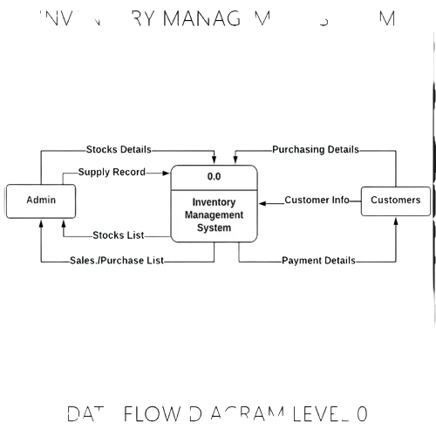**Data Flow Diagram**

**Figure 3. Context Diagram of Developed System for WIMS**

The Context Diagram of the Developed System illustrates the interaction between the Coffee Shop Staff and the Web-Based Inventory Management System (WIMS). The system is specifically designed for the coffee shop and aims to improve inventory management processes.

The Coffee Shop Staff interacts with the Web-Based Inventory Management System to perform tasks such as inventory tracking, real-time stock updates, automatic purchase order generation, and sales tracking. The system utilizes a database to store user information, inventory data, sales records, and other relevant data.

The developed system not only benefits the coffee shop at the Senior High School Expo 2023 but also provides a practical solution that can be used by coffee shops in the community to enhance operational efficiency, reduce costs, and increase profitability.

Overall, the Context Diagram provides a high-level overview of the system's functionality and the flow of data between the Coffee Shop Staff and the Web-Based Inventory Management System.

**SYSTEM ARCHITECTURE**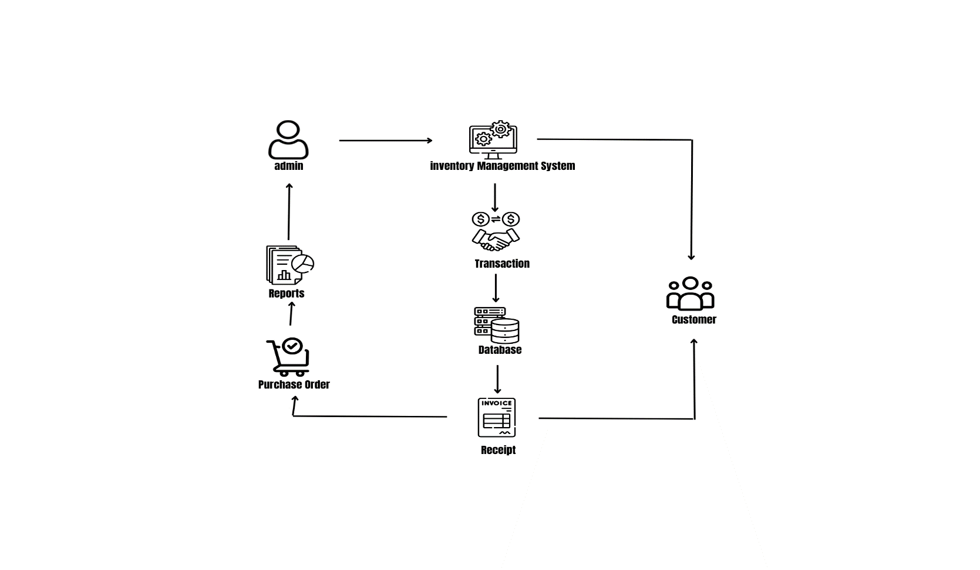

**Figure 3: System Architecture** shows the structural design of the system wherein the employee or cashier can browse the database and can generate invoice. Then if the admin opens the website he can generate reports, purchase order for the suppliers and can manage databases.

**Project Development**

**Table 1. Hardware Specifications for System Development**

|  |  |
| --- | --- |
| **Hardware** | **Minimum Requirement** |
| Processor | Intel Core i4 or higher or AMD equivalent processor |
| Memory | RAM 4GB or higher |
| Disk Space | 150 GB or higher |
| Display | 17inches screen with any resolution |
| Internet Connection | 150mbps internet connection |

**Table 2. Software Specifications for System Development**

|  |  |
| --- | --- |
| **Software** | **Minimum Requirement** |
| Operating System | Windows 10 or Higher |
| Database Management System | MySQL |
| Web Browser | Google Chrome |
| Run-time Environment |  |

**OPERATION PROCEDURE**

To begin, the initial setup involves installing and configuring the inventory management software and POS system on the designated hardware. This includes setting up hardware components like barcode scanners, receipt printers, and cash registers, and establishing a connection between the POS system and the inventory management software for real-time inventory tracking.

Next, you need to set up the products in the inventory management system. This entails adding products to the system by entering relevant details such as SKU, name, description, cost, and selling price. Each product should be assigned a unique identifier or barcode to enable efficient scanning and tracking. Additionally, you should specify the initial quantity of each product in stock.

Once the products are set up, it's essential to track the inventory accurately. This involves updating inventory levels in real-time as products are received, sold, or returned. To facilitate this process, you can use barcode scanners or the POS system to scan and record incoming and outgoing products. Regular physical stock counts should be conducted to ensure the recorded inventory aligns with the actual stock on hand.

During the sales process, the POS system plays a crucial role. To initiate a sale, the cashier or salesperson scans or manually enters the product codes or barcodes. The system retrieves the relevant product details and displays the price to facilitate the transaction. Payments can be processed using the POS system, which accommodates various payment methods such as cash, credit cards, or mobile payments.

Furthermore, it's essential to maintain accurate inventory records by updating the system whenever new products are received, sold, or returned. This helps in maintaining inventory accuracy and facilitates better decision-making regarding reordering, restocking, and identifying popular products.

Regular system maintenance should also be performed, including software updates, database backups, and hardware checks. This ensures the system remains operational and minimizes the risk of data loss or system failures.

Lastly, it's recommended to provide training to the staff members responsible for inventory management and the POS system to ensure proper utilization of the system's features and functionalities.

**TEST PROCEDURE**

To begin, set up the test environment by installing and configuring the inventory management software and POS system. Connect the necessary hardware components such as barcode scanners, receipt printers, and cash registers. Ensure that the test database contains sample product data.

For the product addition test, add a new product to the inventory management system using the provided interface. Verify that all the product details, including SKU, name, description, cost, and selling price, are accurately saved in the system. Confirm that the product is assigned a unique identifier or barcode for tracking purposes.

Next, conduct a test to validate the inventory tracking functionality. Perform various transactions, such as receiving new stock, selling products, and processing returns. After each transaction, check that the inventory levels are updated correctly in real-time. Verify that the system accurately deducts stock when products are sold and adjusts quantities when new stock is received.

Test the sales process by simulating sales transactions using the POS system. Scan or manually enter product codes or barcodes to add items to the sale. Ensure that the system retrieves the correct product details and displays the accurate prices. Complete the transaction by processing payments through the POS system using different payment methods such as cash, credit cards, or mobile payments. Confirm that the system accurately records the sale and updates the inventory accordingly.

Perform system maintenance tests by conducting routine tasks such as software updates and database backups. Verify that the system can be updated without any disruptions and that the data can be successfully backed up and restored.

Finally, provide training to staff members and conduct user acceptance tests to ensure they can effectively use the inventory management system and POS integration. Observe the users as they perform various tasks and validate that the system meets their requirements and expectations.

Document any issues or bugs encountered during the testing process and report them to the development team for resolution.

# EVALUATION PROCEDURE

The ISO Software Evaluation Criteria tool was used by the developer to assess the performance of this system for users. The developer can use this instrument to evaluate the system's applicability for its target purposes and obtain helpful insights into its performance within its environment.

# Table 4. ISO Software Evaluation Criteria

|  |  |  |
| --- | --- | --- |
| **Numerical Rating** | **Categorical Response** | **Verbal Interpretation** |
| 4 | Strongly Agree (SA) | Very Satisfactory |
| 3 | Agree (A) | Satisfactory |
| 2 | Disagree (D) | Needs improvement |
| 1 | Strongly Disagree (SD) | Poor |

The ISO Software Evaluation Criteria's Table 4 displays the degree of acceptability and efficiency of the developed system, as measured on a 4-point Likert scale. The formula utilized to determine the weighted average mean is presented below:

WM = SA*4 + A*3 + D*2 +SD*1 TNR

Where:

WM = Weighted Average Mean

SA = Strongly Agree SD = Strongly Disagree

A = Agree TNR = Total Number of Respondents D = Disagree

**CHAPTER IV**

**RESULTS AND DISCUSSION**

This chapter provides the presentation of information relative to the problem posited. The corresponding analysis and interpretation of data are incorporated in this chapter.

**Functionality Test**

**Table 1 Functionality Test**

|  |  |  |  |
| --- | --- | --- | --- |
| **MODULE** | **TESTING** | **EXPECTED RESULT** | **RESULT** |
| **LOGIN MODULE** | Text field = input characters | All characters inserted including symbols, letters, and numbers are working on the field and has a significant limit of entry. | The system accepts all symbols, letters, and numbers in the field. A low character limit ensures accurate and efficient data entry. |

**Table 2 Functionality Test**

|  |  |  |  |
| --- | --- | --- | --- |
| **MODULE** | **TESTING** | **EXPECTED RESULT** | **RESULT** |
| **ADD ITEM** | Text field = input characters | All characters inserted including symbols, letters, and numbers are working on the field and has a significant limit of entry. | The system accepts all symbols, letters, and numbers in the field. A low character limit ensures accurate and efficient data entry. |

**Table 3 Functionality Test**

|  |  |  |  |
| --- | --- | --- | --- |
| **MODULE** | **TESTING** | **EXPECTED RESULT** | **RESULT** |
| **ADD VENDOR** | Text field = input characters | All characters inserted including symbols, letters, and numbers are working on the field and has a significant limit of entry. | The system accepts all symbols, letters, and numbers in the field. A low character limit ensures accurate and efficient data entry. |

**User Experience Survey Questions**

|  |  |  |
| --- | --- | --- |
| **1.** | **How satisfied were you with the WIMS?** | Shape  **0001** |
| ShapeShapeShapeShapeVery Satisfied         Satisfied         Dissatisfied          Very Dissatisfied |
| **2.** | **How easy was it to navigate WIMS?** | Shape  **0002** |
| ShapeShapeShapeShapeVery Satisfied         Satisfied         Dissatisfied          Very Dissatisfied |
| **3.** | **How likely are you to recommend using the WIMS?** | Shape  **0003** |
| ShapeShapeShapeShapeVery Satisfied         Satisfied         Dissatisfied          Very Dissatisfied |
| **4.** | **Overall, how satisfied were you with the WIMS?** | Shape  **0004** |
| ShapeShapeShapeShapeVery Satisfied         Satisfied         Dissatisfied          Very Dissatisfied |
| **5.** | **Did the system meet your expectations?  If not, please provide feedback and suggestions below** | Shape  **0005** |
| **_____________________________________________________________** |

**User Acceptance Test (According to survey)**

|  |  |  |  |  |  |
| --- | --- | --- | --- | --- | --- |
| **Features** | **5** | **4** | **3** | **2** | **1** |
| **User Interface** |  | ✔ |  |  |  |
| **Satisfaction** |  | ✔ |  |  |  |
| **Functionality** | ✔ |  |  |  |  |
| **Navigation** |  | ✔ |  |  |  |
| **User-Friendly** |  | ✔ |  |  |  |
| **Error-Free** |  |  | ✔ |  |  |

**Result and Analysis** 

For the functionality test, it is stated that the modules met the online registration system’s specific objectives and expected results. In addition, during the functionality test, the programmer was able to detect and resolve errors on the website that were discovered during the testing.

**Summary**

The system is tested in this chapter to ensure that it is functioning as intended and specified in the requirement document. As a result, the system exceeded expectations. The user acceptance test that the website calculated client responded.

**CHAPTER V**   
**SUMARRY OF FINDINGS**

This chapter deals with the summary that provides all the important results obtained in this study, conclusions that give meaning to the observations, and recommendations that discuss how the results fit into a broader context.

**CONCLUSION AND RECCOMENDATIONS**

**Conclusion**

The researchers conclude that WIMS is effective. As opposed to using pen and paper, the system allows for faster and usable. The proposed system also aims to make clients' tasks easier.  The researchers also conclude that the system's features need to be improved in the future to make it more efficient for users.

**Recommendations**

The following are the feature recommendations for the future researchers:

1. Mobile Application:

Develop a mobile application that allows users to access the inventory management system and perform essential tasks remotely.

1. Supplier Management:

Include features to manage supplier information, such as contact details, pricing agreements, and delivery schedules.

1. Batch and Expiry Tracking:

Incorporate functionality to track and manage products with batch numbers and expiration dates.

**References:**

iNetTutor.com. (2019, August 31). Inventory Management System Review of Related Literature. *iNetTutor.com*. https://www.inettutor.com/source-code/inventory-management-system-review-of-related-literature/

Matillano, K. (2020). Chapter 2 | Related Literature | Sales and Inventory System. *Itsourcecode.com*. https://itsourcecode.com/fyp/chapter-2-related-literature-sales-and-inventory-system/

Ambigouselee. (n.d.). *Sales and Inventory System - College Essay - Ambigouselee*. <https://www.papercamp.com/essay/72264/Sales-And-Inventory-System>

Hayes, A. (2023). Inventory Management Defined, Plus Methods and Techniques. *Investopedia*. <https://www.investopedia.com/terms/i/inventory-management.asp>

**APPENDIX**

**Appendix A: User’s Manual**

**Figure 1. showing the landing page**

**Figure 2. Admin Login Module**

**Figure 3. Add Item**

**Figure 4. Upload Image to Item**

**Figure 5. Purchase Stock**

**Figure 6. Add Vendor**

**Figure 7. Add Sale’s**

Figure 8. Add Customer

**Figure 9. Item, Sales, and Purchase Reports**

**Appendix B: User Acceptance**

